DURHAM AUTOMOBILE CLUB
QUARTERLY NEWSLETTER
JANUARY 2015
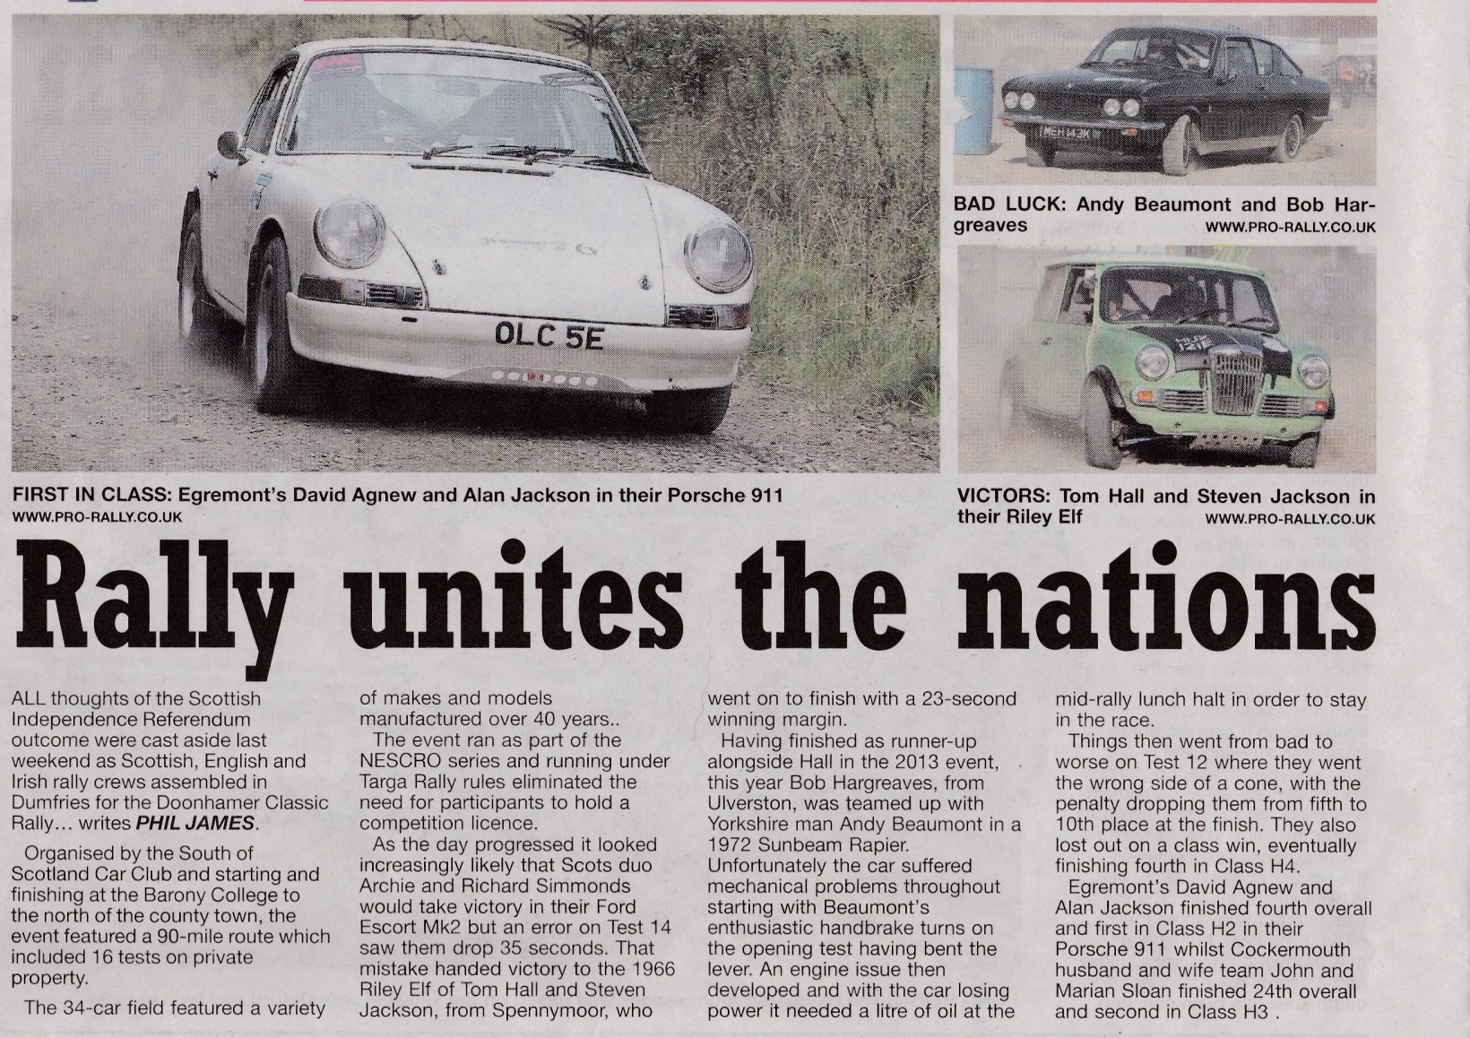
Durham crews make national headlines in Scotland (Northwest Evening Mail)
Disclaimer: Articles supplied are the views of the author(s) and not necessarily those of the club or other members.
All articles for April’s copy to be supplied to Bernie Pugh (maddogd9@tiscali.co.uk) by the end of March.
3 Christmas Autotests
Eden Valley Motor Club
The first one was Sunday 21st at Penrith Auction mart. It was ran as an autosolo and used the full perimeter road. A mini Tarmac rally really. Dead easy to follow, but with chicanes in to slow you down. 21 starters lined up. The most unusual was a Reliant Kitten, which went very well for an 850. It is to get a motor bike engine this year, probably to do sprints. There is another one out there with a Honda Civic engine which did The Teesside sprint last year. Tom brought out yet another new mini. It had teething problems with clutch, but looks very quick.
I finished about half way up the field. Lack of power on the long straights was my problem. Phil and John in the RWD MK3 escort were very entertaining to watch. It was won by a Puma in the end.
Durham Auto Club
This one unfortunately clashed with the Christmas Stages. Early ice made the first runs a little tricky, but put smiles on everyone's faces. Two test sites were run at the same time, which means we all had lots of runs.
Half the field did a proper autotest and the other half did an all forward one. The autotest being won by a Nova brought down from Dumfries. It was a battle between the 3 Nova drivers and the Styker drivers., beating the Mini's.
The all forward being won by Tom in an Elf. I think I finished about halfway up the field. Lack of skill being the problem.
Hartlepool Motor Club
This one was held on Sunday 4th January. The annual Plum Pudding Autotest. 25 drivers were entered for this event. Again, early ice made for some interesting driving. The whole car park was used for one test. That meant it was very fast, but only managed to get four runs in.The tests were hard to learn, because of their length. Must have walked miles, trying to learn the route. Memory is not what it used to be. It was all forward, with nothing tight, so any car could win. In the end it was Tom in a borrowed Clio that won. A brilliant drive in a standard car. His Mini clutch went first test. Still not sorted it properly after the Penrith event.
Paul Swift had a wheel fall off mid test. Wheel stud's snapped. The rear wheel drives were all struggling for grip on the ice. The Mini's were running out of gears. I managed 2nd FWD behind Ben in the Micra. The RWD's were again a joy to watch. Excellent car control.
A good day out, but would have liked two tests running and more compact route. £25 is a bit much for 4 tests for us poor retired people. Archie could only marshal. Got his Escort back, but completely stripped.
Next ones, Dumfries on the 18th, Maryport on the 25th.
Peter Masters
Roger Albert Clark Rally from Hamsterley to Harwood
A belated thank you to everyone from Durham Auto Club and associated friends who came out in appalling weather on the Friday night to marshal in Hamsterley. The arrangement of arrival and start, a double running stage and the same access and exit road coupled with a large number of spectators made it very, very interesting! The evening also included the recovery of a competitor who had underestimated the size of his car, and overestimated the amount of available road! A brief hold on the stage and a Land Rover were all that was required! Despite that both arrivals and start ran very smoothly, with competitors commenting on how well organised the marshal were.
Saturday saw a number of club members returning to Hamsterley for the Saturday stages. Once again they ran smoothly with the arrival and start being very professional.
Instead of a second day in Hamsterley I headed to set up Harwood, which was our Sunday stage. Thank you to Gogs, George, Gavin and Bobby for their invaluable help with the stage set up.
Sunday saw the best weather of the weekend, and a very early start. The sunrise over Simonside was something to behold. The stage ran well and with little incident. It was a shame that Harwood only ran once as the stage was in fantastic condition, and I managed to drive out in my little Volvo C30! Thank you to everyone who endured a very early start to assist with marshalling, and to the MG Car Club and Tynemouth and District Motor Club who looked after the flying finish and stop.
Hopefully we’ll be invited to do it all again next year!
Lindsay
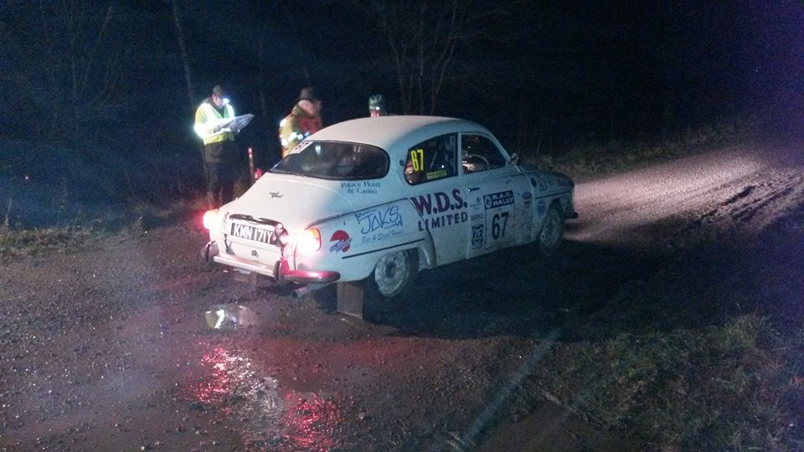
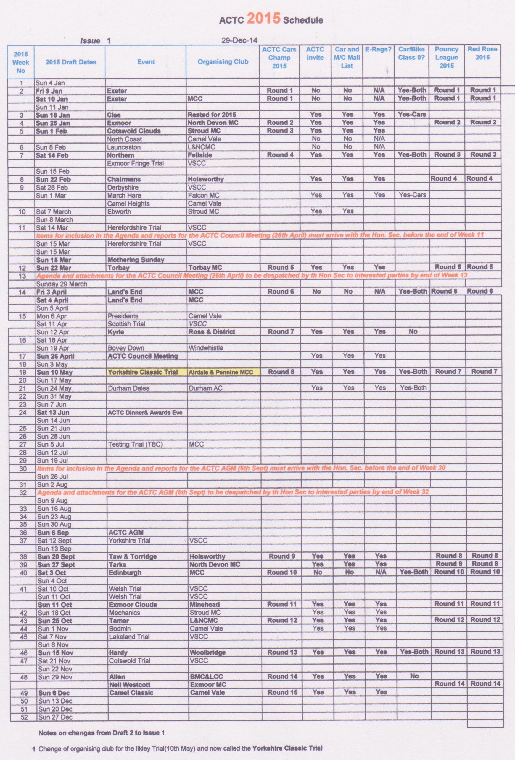
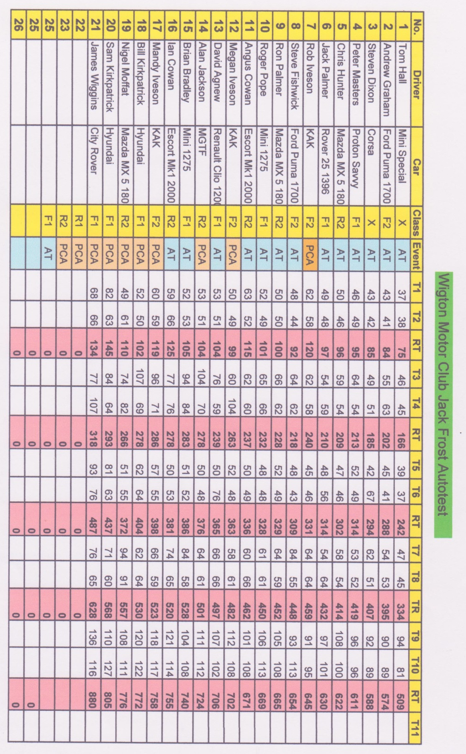

Results from Graeme after Sunday 25th January. As you can see, Masters and Hall have been at it again, travelling over to Maryport to compete in the Wigton Motor Club Jack Frost Autotest. Hopefully we’ll have an article from either Tom or Peter for the next magazine.

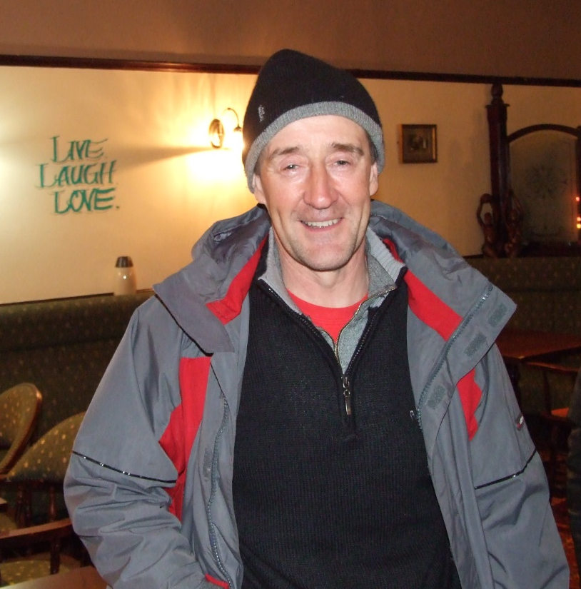
Peter Masters smiling again!!
A good night was had by all.

On Wednesday 28th January, it was the AGM and Awards Night at The Salutation at Framwellgate Moor, where the club now meets on a Wednesday night. Graeme Lowden had taken time out of his busy schedule to travel five and a half hours from Banbury in appalling weather to give a presentation and enlighten us on the trials and tribulations of Formula 1. He told us about how Marrussia are looking forwards with a light hearted talk covering many aspects of motorsport. His talk was well received and it was obvious that he had a great love and passion for all forms of motorsport.

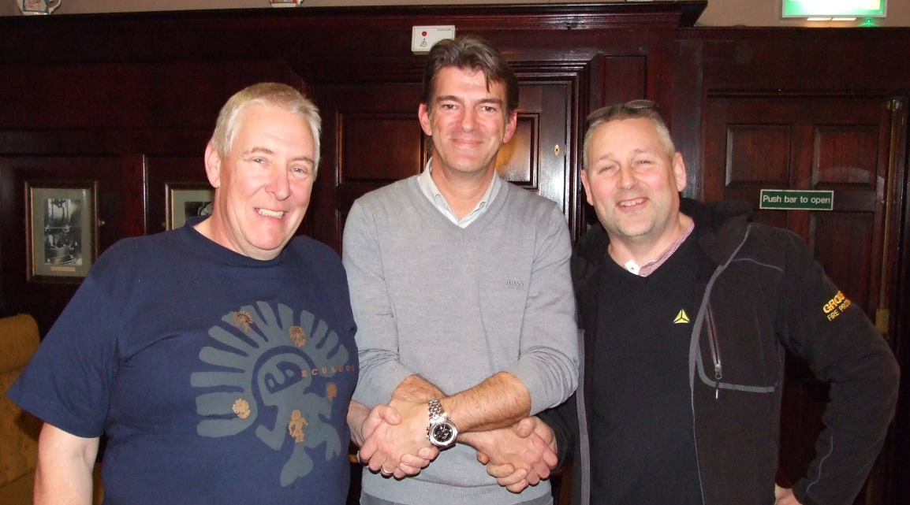
Tom Hall (Chairman), Bernie Pugh (Vice-Chair) thank Graeme for his time and excellent talk.

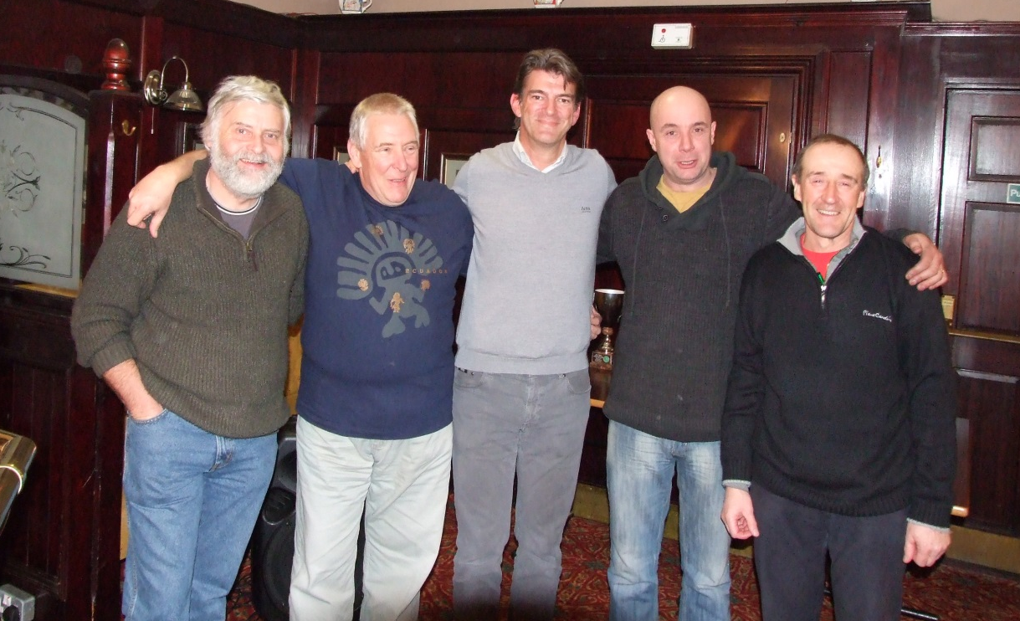
Other committee members show their appreciation for Graeme travelling up
(and if he didn’t drive that stupid Maserati, he could have done it in 4 hours!)
L-R: Mick Stead (ACTC rep), Bernie Pugh (Vice Chair), Graeme Lowden (Marrussia), Tony Chrisp (Competition Secretary) and Peter Masters (Membership Secretary)
Positions elected at the AGM
28th January 2015

Durham Automobile Club Committee for 2015
President | Nicky Porter | tba
Chairman | Tom Hall | 07946515848
Vice Chairman | Bernie Pugh | 07835407626
Secretary | Joan Wood | 0191 3842461
Treasurer | Colin Payne | 07525487144
Membership Secretary | Peter Masters | 07754046543
Competition Secretary | Tony Chrisp | 07596862711
Chief Marshal | Peter Sewell | 01388 747223
Social Secretary | Colin Payne | 07525487144
Magazine Editor | Bernie Pugh | 07835407626
Website/Facebook | Lindsay Burnip/Mark Thornton | tba
Press Officer | Jean Payne | 07525487144
Child Protection Officer | Julie Pugh | 0191 3735670
Junior Representative | Johnny Chrisp | N/A
Autotest Co-ordinator | Tom Hall | 07946515848
Committee Members
Neil Foster [Year 3]
Gordon Dundee [Year 2]
Andy Brown [Year1]
Mick Stead [Year 1]
David Pugh [Year 1]
Mark Thornton [Year 1]

Hopefully More Articles On Awards Night Next Magazine.

