
DURHAM AUTOMOBILE CLUB LTD.

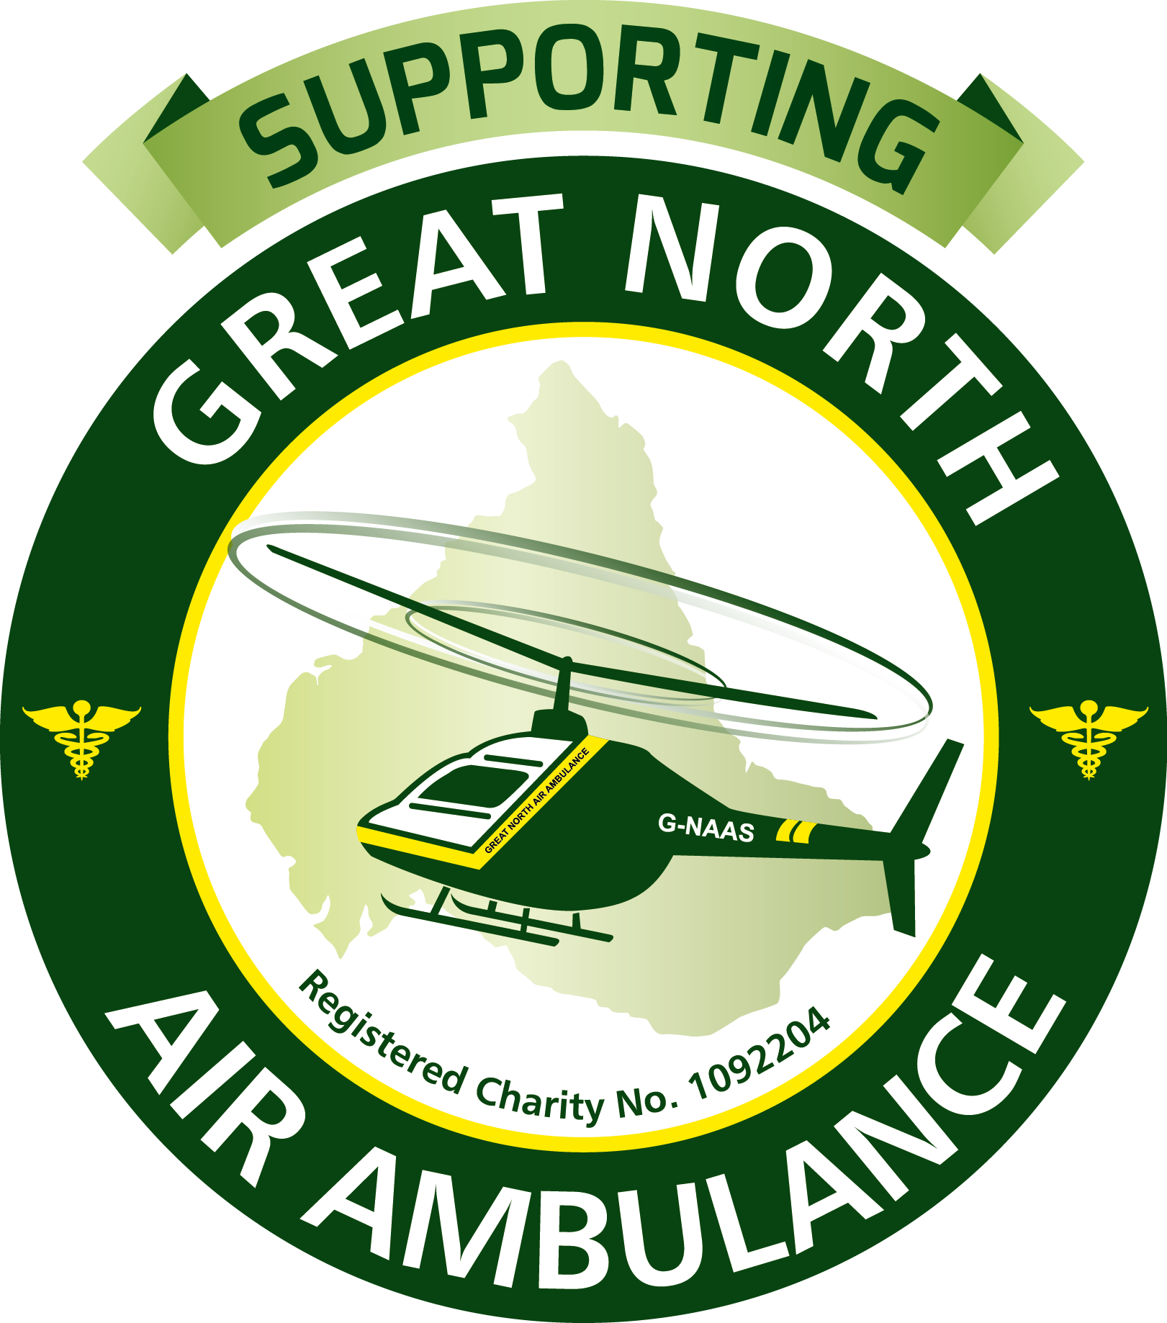

CLASSICS at the CASTLE

And AUTO JUMBLE at Witton Castle SUNDAY 15th July 2018 11am – 4pm.

REGULATIONS, INFORMATION & ENTRIES

Durham Automobile Club will hold a CAR & VEHICLE DISPLAY and Auto Jumble at Witton Castle on Sunday 15th July 2018. Open to the PUBLIC from 11am – 4pm.

OUR NOMINATED CHARITY THIS YEAR IS THE GREAT NORTH AIR AMBULANCE The Air Ambulance is a fantastic service that we might all need one day! Whether competing in an event, travelling by road or even finding yourself in an emergency situation at home. We will be delighted, with your help, to generate some additional funds for them.

EXHIBITORS and Auto Jumble tables must be in position NO LATER than 10.15 am (Gates open 8 am)
Once in place to ensure a safe and secure environment for the public and exhibitor’s movement of vehicles before 4pm is restricted. (Anyone needing to leave before 4pm must make prior arrangements with the organisers)

The Event will finish at approximately 4pm (or a little later depending on final awards presentation)

When arriving and leaving all vehicles must obey the speed limits on site and keep exhaust noise to a minimum, this is a holiday park as well and there will be children and dogs in all public areas and access roads. There is a strict one way system which is clearly marked and additional arrows will also be in place.

Please follow signage and marshals. Please use the litter bins provided or take your litter home.

Durham Automobile Club want this to be a great day out for everyone so please do not hesitate to contact members of the committee, organising team or marshals if you have any questions or concerns at ANY TIME. (You will find some contact details at the end of these regulations if you wish to speak with anyone beforehand)

ENTRIES All entries must be made on the official Entry Form Photo copies are acceptable. (You only need to complete and return appropriate form) and send the correct fee. RETURN BY POST OR EMAIL

Entries open on the publication of these Regulations.

ENTRIES CLOSE SATURDAY 30th JUNE NO LATE ENTRIES WILL BE ACCEPTED

!!!!! DISCOUNTS FOR EARLY ENTRIES !!!!!!

All entrants will receive, by post, one week before the event Final instructions, map of the site and Class Tickets to be displayed in the windscreen in order to aid marshals/parking on the day. POSTAGE costs are included in your entry fee. Entry fees can be paid by CHEQUE, BACS, CASH or PAYPAL as per instructions on entry form.

REGULATIONS & INFORMATION continued.....

COMPETITION CLASSES & CAR DISPLAYS

INDIVIDUAL CARS/Vehicles for show and to be judged by class
There will be the following classes, all of which will be judged on the day for 1st 2nd and 3rd in class
Cars to be MANUFACTURED: Pre 1960’s, in the 1970’s, 1980’s 1990’s, Millennium (2000 to now) and Modified

There will also be 2 classes for MOTORCYCLES (Vintage & Classics/Modern) A class for TRACTORS

Any Other Vehicles (can be buses, light commercials, military etc etc). May be subject to weight limit please enquire.

PERPETUAL AWARDS & trophies for Best In Show and 1st places in all classes, awards 2nd & 3rd in class ALL entrants receive personalised certificate.

Car Clubs, Owners Clubs and other Groups can book a stand space FOR THEIR GROUP. Space will be allocated dependant on the number of cars to be displayed. Cars/vehicles coming as part of a group and displaying together WILL NOT BE JUDGED as individuals but there will be an award for the BEST/MOST INTERESTING Stand.

AUTO JUMBLE – New and Used/pre owned!

Auto Jumble stands are for the sale of car/motorcycle and vehicle related parts, tools, equipment, memorabilia, books & magazines etc. New items can be sold but must be as above. ( STRICTLY NO items that can be deemed ‘offensive’ in any way- no firearms, knives or ‘weapons’!)

Any other Commercial/Business wanting to exhibit may contact the organisers to discuss requirements such as pitch size. Businesses pay the standard fee as per entry form PLUS a donation to GNAAS.

TRAILER PARKING available if required.

CONTACT DETAILS:

Event Secretary/Organiser Pam Broom Tel: 07733 243842.. EMAIL: pam.broom@btinternet.com
4 WOODSIDE, WITTON PARK, BISHOP AUCKLAND, CO. DURHAM DL14 0DS

Chairman Andy Brown 07756 449651 email: durhamautomobileclub.com

Vice Chairman (& health & Safety Officer) Chris Thirling: 07745 737917 email: chris.thirling@gmail.com

Chief Marshal John Ward: johnward.mailbox@gmail.com

PLEASE ALSO SEE:

DAC website DAC Facebook GREAT NORTH AIR AMBULANCE web site & Facebook

VENUE: Witton Castle Country Park, Witton Le Wear Co Durham DL14 0DE
MR: Map 92. (Entrance) 157 294

BY KIND PERMISSION OF Shorewood Leisure Group.

Facilities on site include Toilets, Bar, Restaurant, Woodland Walks and children’s play area

DURHAM AUTOMOBILE CLUB LTD.
CLASSICS at the CASTLE

And AUTO JUMBLE at Witton Castle SUNDAY 15th July 2018 11am – 4pm.
ENTRY FORM (1)

CAR DISPLAY & COMPETITION (Cars to be MANUFACTURED within these dates)
Please tick box for the class you are entering.

Pre 1960’s 1960’s 1970’s 1980’s 1990’s

Millennium Modified Tractors Any other Vehicle please describe below

DAC & Invited Competition Cars

Motorcycles (Vintage/Classic Pre 1980) (Modern 1980 to date)

VEHICLE DETAILS:
MAKE.........................................................MODEL..............................................REG.No..............................
..................................................................................................................................................
ENTRY FEES: Entries and payments BEFORE 31st MAY – DISCOUNTED RATE

£5.00 per Vehicle incl Motorcycles and Tractors

Entries between 1st June and 30th June £10.00 per Vehicle incl Motorcycles and Tractors

CONTACT DETAILS

Name ................................................................................ Motor Club......................................................
Address...............................................................................................................................................................
Post code.............................................................
Contact No......................................................................................
Email:..............................................................................................................................................................

PAYMENTS (please tick your payment method)
Entries & fees must be received by Saturday 30th JUNE at latest
SORRY but NO LATE ENTRIES can be ACCEPTED
Preferred payment is by Bank Transfer BACS/faster payment to Santander
ACCOUNT DETAILS: Sort Code : 090666 Account Number: 42772324 Reference: your name
PAYPAL to : dac.secretary@btinternet.com
OR Cheques ( Payable to Durham Automobile Club) can be posted to DAC Ltd at

4 WOODSIDE, WITTON PARK, BISHOP AUCKLAND, CO. DURHAM DL14 0DS
TEL: 01388 604193 or EMAIL: pam.broom@btinternet.com
DURHAM AUTOMOBILE CLUB LTD.
CLASSICS at the CASTLE

And AUTO JUMBLE at Witton Castle SUNDAY 15th July 2018 11am – 4pm.
ENTRY FORM (2)

CAR/OWNERS CLUBS/GROUPS

Name of Club/Group...................................................................................................

Description/Makes of type of vehicles..................................................................................................

Number of vehicles to be on stand.......................................................................................................
Please include below the contact details below of the main contact person for this event.
..................................................................................................................................................
AUTO JUMBLE. Restricted to Auto parts, tools & equipment and memorabilia

Auto Jumble tables will be sited slightly apart from the show classes so as not to impede judging and spectators and for safety reasons.
COST £10.00per table/person before 31st May or £15.00 after 1st June
- I would like to book a space for the AUTO JUMBLE ( please tick) here ..............................
..................................................................................................................................................
ENTRY FEES: Entries and payments 31sy MAY – DISCOUNTED RATE

£10.00 Vehicle/Table Private Individual........ ( BUSINESSES PLUS donation to GNAAS on the day)

Entries between 1st June and 30th June

£15.00 Vehicle/Table Private Individual.........( BUSINESSES PLUS donation to GNAAS on the day)

CONTACT DETAILS

Name ................................................................................ Motor Club......................................................
Address...............................................................................................................................................................
Post code.............................................................
Contact No......................................................................................
Email:..............................................................................................................................................................
PAYMENTS (please tick your payment method)
Entries & fees must be received by Saturday 30th JUNE at latest
SORRY but NO LATE ENTRIES can be ACCEPTED
Preferred payment is by Bank Transfer BACS/faster payment to Santander
ACCOUNT DETAILS: Sort Code : 090666 Account Number: 42772324 Reference: your name
PAYPAL to : dac.secretary@btinternet.com
OR Cheques ( Payable to Durham Automobile Club) can be posted to DAC Ltd at

4 WOODSIDE, WITTON PARK, BISHOP AUCKLAND, CO. DURHAM DL14 0DS
TEL: 01388 604193 or EMAIL: pam.broom@btinternet.com

